# **LAB 1 - AIG140 - ADVANCED DATA VISUALIZATION**

Group 02 Members:

* Masoud Masoori
* Aliyyah Jackhan
* Mohammed Aadil Suhail Shaikh
* Jonathan Chacko Pattasseril

Instructions:

* Choose either one or two of the datasets from either of the following challenge sites:  
  MakeoverMonday: <http://www.makeovermonday.co.uk/>   
  TidyTuesday: <https://github.com/rfordatascience/tidytuesday/tree/main/data>
* Each dataset on these sites provides a challenge to come up with an effective visualization. MakeoverMonday gives an original visualization you are trying to improve on, while TidyTuesday simply challenges people to come up with their best attempt.
* Search social media (usually [X/Twitter](http://x.com/) or [Tableau Public](https://public.tableau.com/) are good bets) using the hashtag #makeovermonday or #tidytuesday, along with appropriate keywords from the dataset description. Find two solutions to each challenge, if you chose two datasets, or three solutions for the one dataset, if you chose just one.
* In your lab report:
  + Show, interpret, discuss and critique the visualization, in reference to the given data set.
  + Compare and contrast the different visualizations for the same dataset.
  + Discuss ways to improve on at least two of the visualizations.
  + You do NOT need to create a new visualization—you need only discuss your ideas for improvement. If you really want to illustrate something you can, but it is enough to provide a rough paper and pencil sketch.
  + Be prepared next week to discuss your findings with the rest of the class, time permitting.

**About the Dataset**

Link to the dataset: [A few world heritage sites](https://github.com/rfordatascience/tidytuesday/tree/main/data/2024/2024-02-06)

Quick Information about the dataset:

The dataset consists of a small csv data representing number of UNESCO world heritage sites in 2004 and 2022 in Norway, Sweden and Denmark.

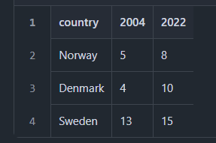

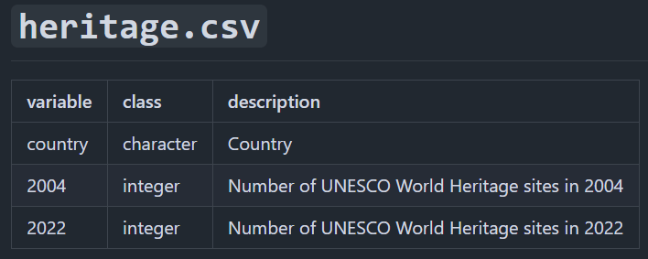

**Visualization 1**

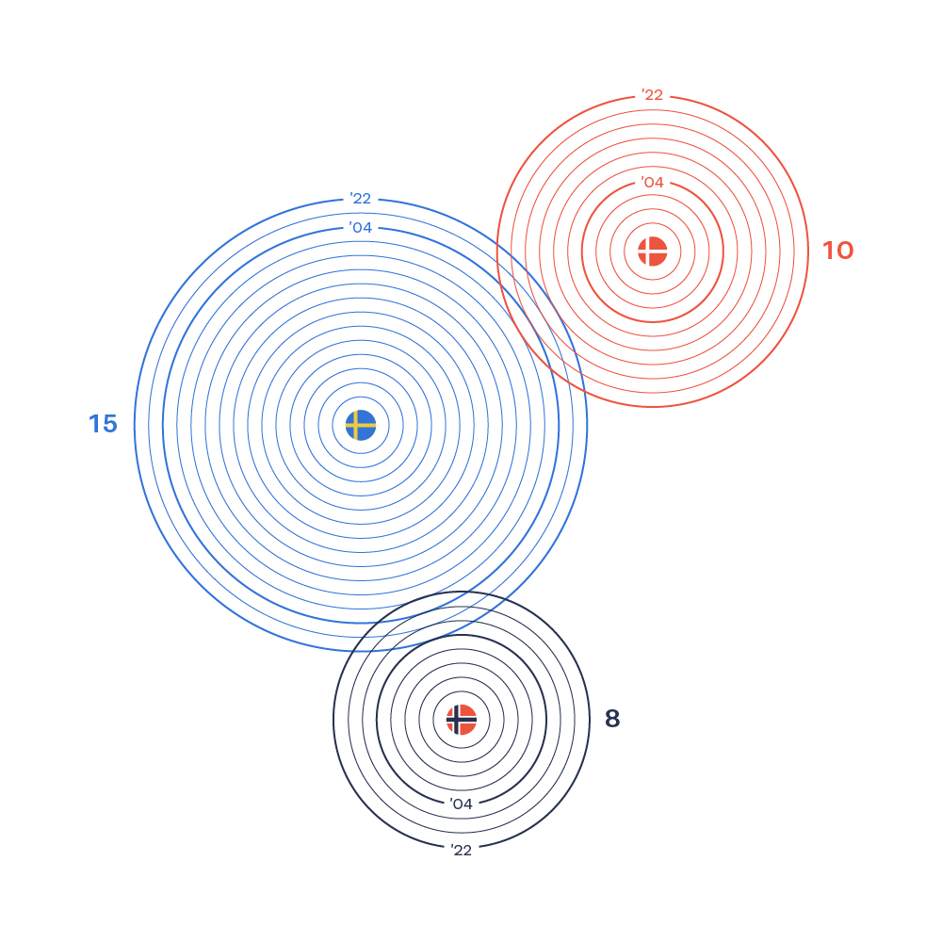

Figure

This data visualization uses circles to represent the number of World Distribution Sites in Norway, Denmark and Sweden in 2004 and 2022. Initial improvements I would make to this visualization are adding titles to explain what the data represents (chart title, country names) as well as a legend to explain what each circle represents. As this is nontraditional, it can be difficult for someone to interpret the data at first glance. I would recommend separating the circle as the overlapping is a confusing design choice.

A better way to represent this data in a similar way would be to have two pie charts or donut charts showing the number of World Distribution Sites in each country in 2004 in one, and 2022 in another. This way it can easily be understood the number of sites in each country in 2004 and the change in values in 2022.

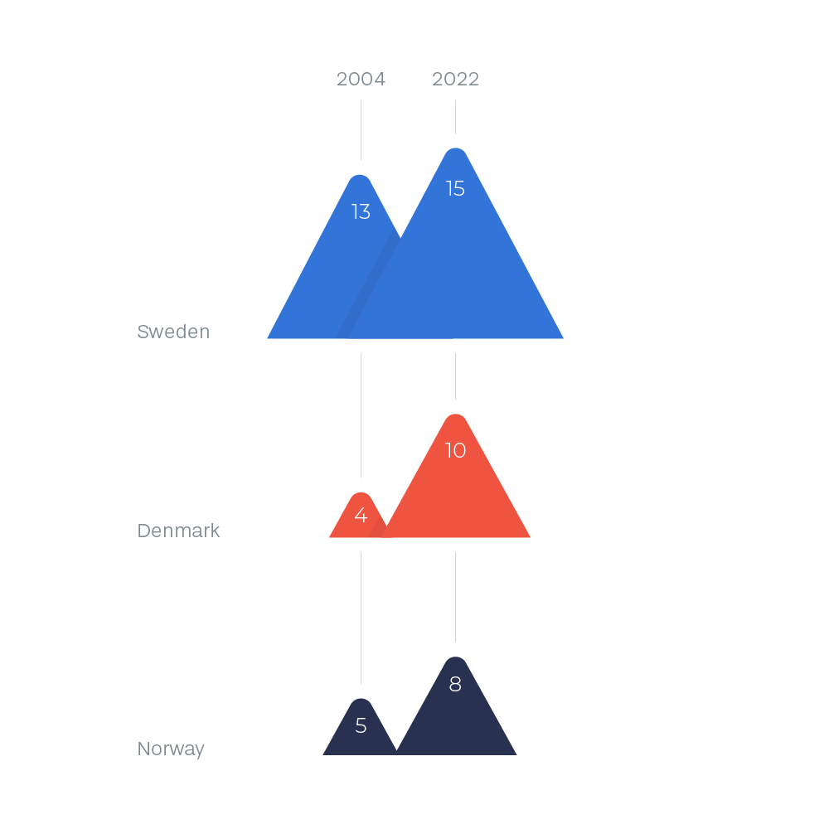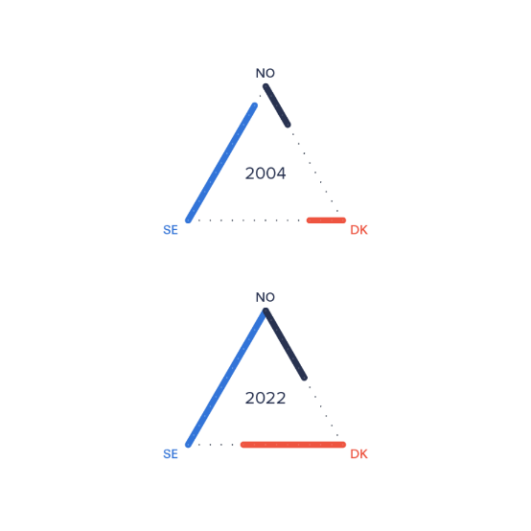**Visualization 2**

Figure (left) and Figure 2 (right)

In the figure 1, Triangle looks appealing but at first glance most people will struggle to understand it as it is an unconventional data visualization. On the contrary, if we are opting for triangles as the way to represent the data, figure 2 provides more details like the stating the full names of the countries and having x-y axis to show the progression.

Main Problem’s and its Respective Fix’s in the above visualization are

|  |  |
| --- | --- |
| Problem | Fix |
| No Numerical Scale | A Scale to Represent each Dot as 1 Unit |
| The Shortforms for Countries are Confusing | Flags or Full Form’s would have been a better Representative of the Data |

**Visualization 3**

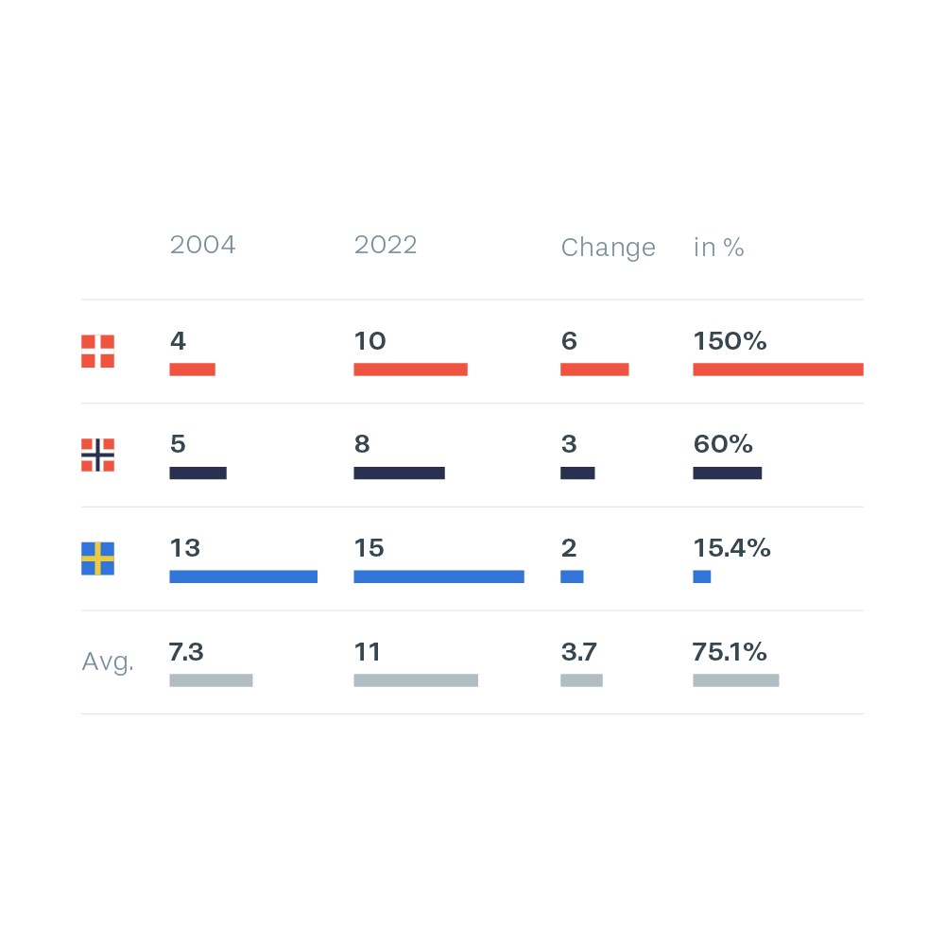

Figure 3

This chart gets right to the point. It’s easy to read, easy to compare, and provides the key takeaways without overwhelming the viewer. It’s a perfect balance of clarity and style, making it a great model for anyone who wants to show trends over time in a simple, impactful way.

**Visualization 4**

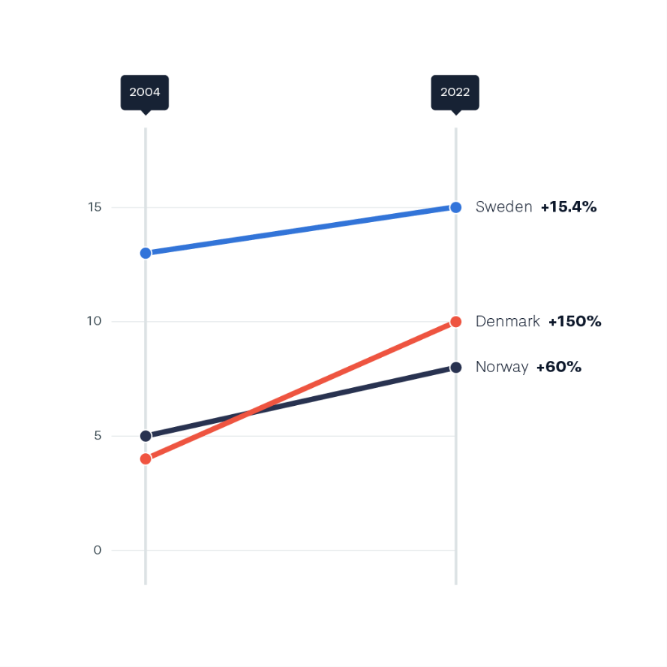

Figure 4

In our opinion we consider this Visualization to also be an Ideal representation of the data set, and it helps us tell the story of which the data provides.

* It shows a Clear Comparison between the Year’s
* All Values are clearly highlighted in the Visualization
* It not only highlights growth visually in a simple way but also has added the percentage of growth for each Country, so the Viewer has the clear Idea without having to do any mental Calculation.
* It looks clean and professional.